How to Switch Payroll Software in Mid-year

Steps to Enter YTD Data Manually

ezPaycheck payroll software help you process payroll taxes, print paychecks and file tax forms easily and smoothly.
If you have not installed this software, you can download and try it free for 30 days with no obligation and no credit card needed.
This paycheck software is compatible with Windows 8, 7, XP, Me, 2003, 2000 and Vista system.

YTD means Year-to-date. It is a period from the beginning of the current year, and continues up to the present day. The YTD information on the check stubs will update automatically each time you add a new paycheck.

This YTD entry feature is for users who start ezPaycheck in mid-year. (If you start ezPaycheck from Jan 1, you do not need to enter YTD manually.)

For example, company ABC handles paychecks for employee Ryan Smith manually from 1/1/2011 to 6/30/2011. They plan to use ezPaycheck from 7/1/2011-7/15/2011 pay period. So instead of entering the old checks one by one, they can enter the YTD summary data here.

You should add the YTD data first before you generate a new paycheck. So you can see the correct YTD data on paycheck stubs.

Here are the steps.
If you have not installed ezPaycheck payroll software, you can download it from
http://www.halfpricesoft.com/payroll_software_download.asp
Step 1: Set up company information

Step 2: Add a new employee Ryan Smith

Step 3: Select Ryan from Employee list and open YTD manually input screen. Then enter the summary information for 1/1/2011 to 6/30/2011.

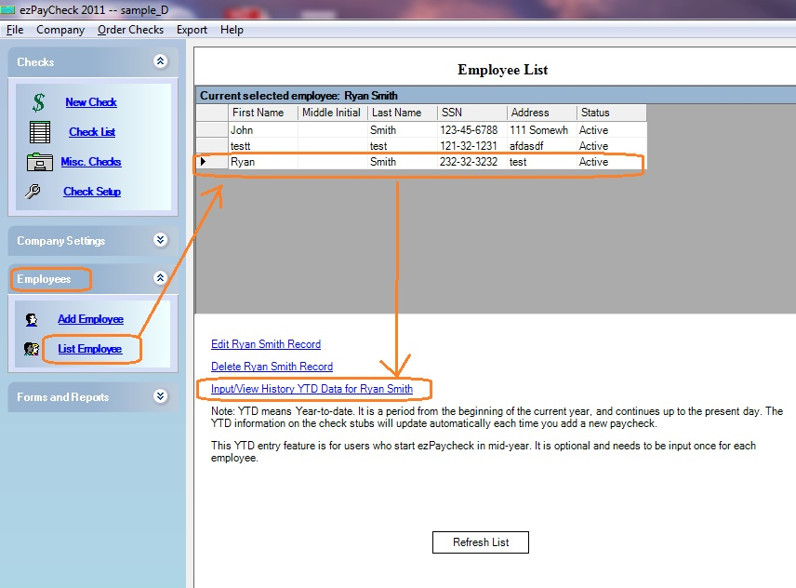
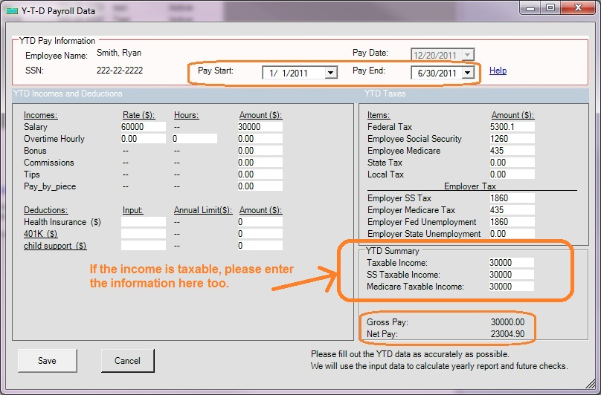

Step 4: When you generate a new check, you will see the YTD data is updated.
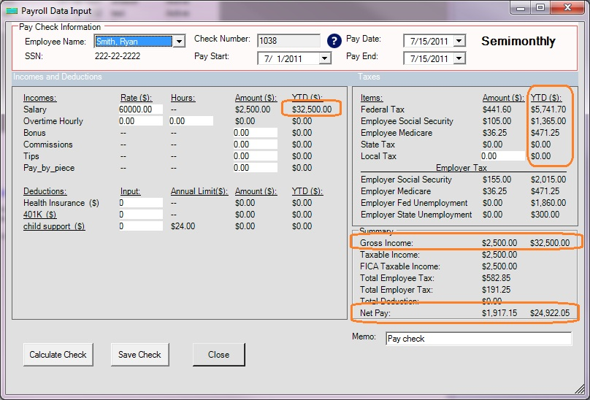
To learn more about ezPaycheck, visit http://www.halfpricesoft.com/index.asp
Related article: How to enter paychecks for after the fact payroll

